07.05.2025

**HOSPITAL MANAGEMENT SYSTEM**

**AKIRA HOSPITAL MANAGEMENT**

List of similar products:

|  |  |  |
| --- | --- | --- |
| Product name | features | URL |
| HMS | Doctor Side: Patient management, appointment scheduling, diagnosis & prescription updates.  Patient Side: Appointment booking, medical history access, secure diagnosis & prescription viewing.  System Features: Prevents clashes, enhances privacy, and ensures smooth hospital operations. | https://github.com/hrishikeshathalye/Hospital-Management-System-DBMS |

Name : DIVYA K  
Roll No :927623BAD029

Official I’d : [927623bad029@mkce.ac.in](mailto:927623bad029@mkce.ac.in)  
Personal I’d: [kaliyappandivya1974@gmail.com](mailto:kaliyappandivya1974@gmail.com)  
Mobile No : 6374598088

**Contribution :** Table normalization, Form design, connecting to the DB, Reports, Schema design   
------------------------------------------------------------------------------------

Sites.google.com  
Portfolio  
Git hub : kaliyappandivya1974  
Leet Code

Tables

* Doctor-Master
* Patient-Transaction
* Appointment-Transaction
* Billing

Master - Doctor table

Doctor _id -primary key

Doctor _name

Specialization

Transaction -Patient

Patient-id-primary key

Patient _name

Doctor _id -foreign key

Appointment table :

Appointment _id-primary key

Patient _id

Doctor _id

Billing table

Invoice _ id-primary key

Patient _id-foreign key

Doctor _id-foreign key

Total _value

**Create Table doctor(**

**Doctor _id varchar(225) primary key,**

**Doctor _name varchar(225),**

**Specialization varchar(225) );**

**select * from doctor**

**insert into table**

**create view**

**key words:**

Relation-doctor,

Attribute-doctor _id,

Domain-doctor _id start with AKdoc,

Tuples-value

**Database normalization:**

* 1NF
* 2NF
* 3NF
* 4NF
* 5NF

Doctor table :

My table is in **1NF** because it has a primary key named

doctor _id

My table is in **2NF** because it has a primary key -doctor _id, all other columns all dependent on the primary key

**3NF**:  
Should be in 2NF   
No transitive partial dependency

Example:

|  |
| --- |
| Student _id, Student _name,Job _id,Job_name,state_id,state_name |
| 927623bad029 | DIVYA K | J_0129 | Programmer | 29 | Namakkal |

**1NF:** Student _id, Student _name,

**2NF:**  
Student _roll   
Student _id, Job _id

Student info table:  
Student _id, Student _name, State _id, State _name

Job table:

Job _id, Job _name

**3NF:**

Student roll table:

Student _id

Job _id

Student info table :

Student _id

Student _name

State _id

Job info table:

Job _id

Job _name

State _name

Front end : HTML,CSS, react.js , tail win CSS, flask, android, flutter,

Back end : SQL, oracle, mongo DB, JSON, SQL lite, firebase

Editor : VS code

Frame work : XAMPP v3.3.0, node.js

Language : php, python

Example:   
Doctor – parent tag(table name)

Doctor _id, Doctor _name, Specialization

**DTD**

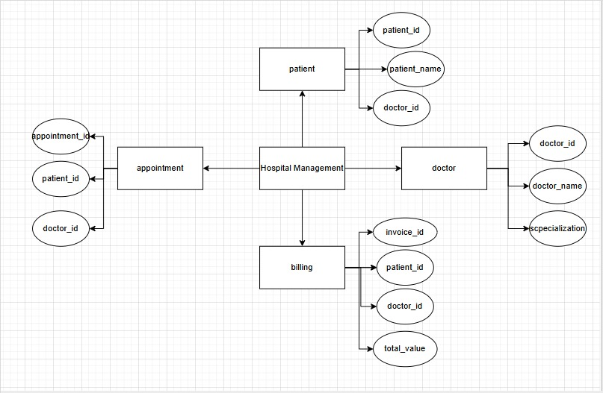

DTD with no elements:

<login timeout=”100”/login>

<!element login empty>

<!ATTLIST login timeout CDATA “100”>

**JOIN:**

**Inner join**

Select * from doctor

Inner join patient on doctor.doctor_id=patient.doctor_id;

Module details

|  |  |  |
| --- | --- | --- |
| Module name | sub module details | description |
| Doctor Management | Add doctor | Register doctors with specialization and qualifications |
| View doctor | List of doctors with availability status |
| Doctor schedule | Manage consulation hour and leave schedule |

Form details:

|  |  |  |  |  |
| --- | --- | --- | --- | --- |
| Module name/submodule name | Form name-type | Form description | Table name-type | Table description |
| Order/Book order | Book order form-transaction,  master | I can see the food items list and book for the order | Order table-transaction | Orders are linked here |
| Appointment /schedule appointment | schedule appointment-transaction | I can schedule appointment booked for doctors/  patients | Appointment table-Transaction | Book appointments with doctor/patients |